Aws Cloud Task -1

- Launch one EC2 using Amazon Linux 2 image and add a script in user data to install Apache.
- First go ec2 using amazon linux and select launch instances and added name of the server cloud, scroll down.
- Advanced details > userdata > enter the script in the box and launch instance.
- Copy public id and paste it in browser and add port number 80 at the end of it enter
- We can see “It works” if it is working.
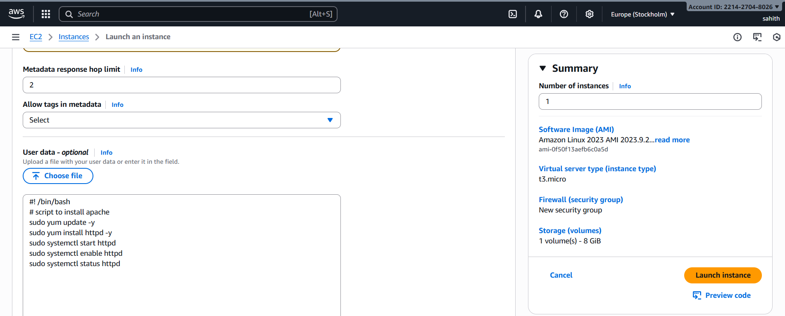
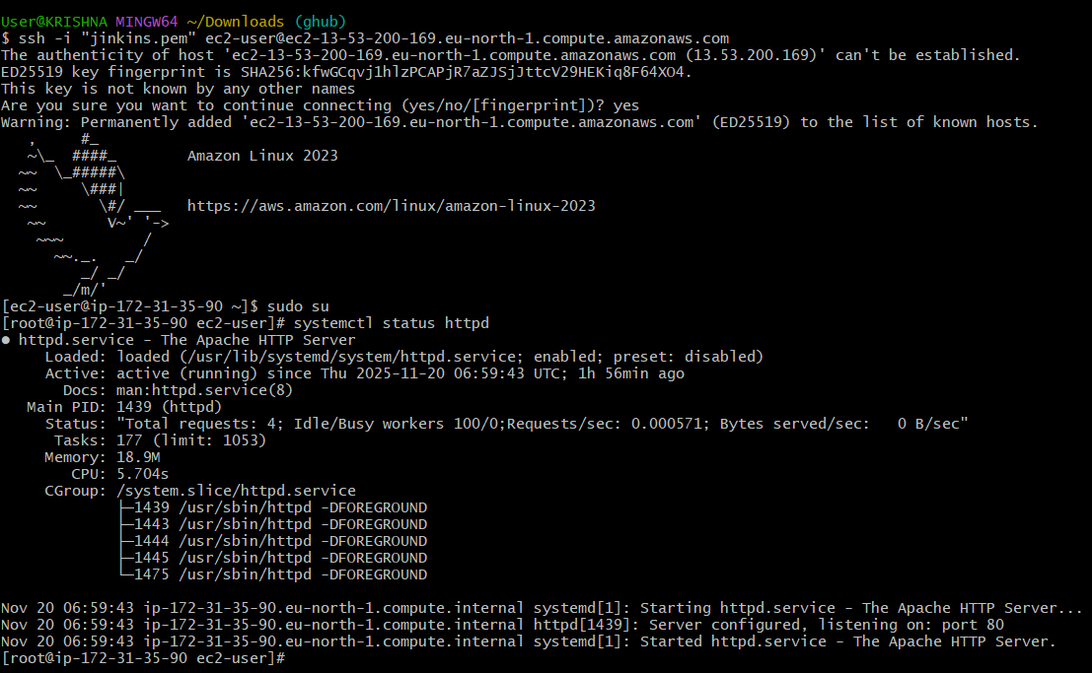
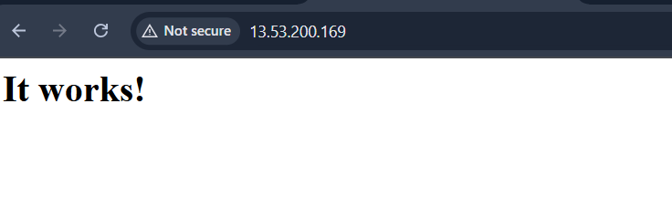

- Launch one EC2 using Ubuntu image and add a script in user data to install Nginx.
- Go to aws console > ec2 >instances >launch instances
- Enter name nginx server > choose Ami > unbantu server
- Choose instance type : t2.micro (free tier)
- Choose a key pair : Jenkins
- Under network settings: all traffic
- Go advanced details > userdata > enter the script in the box and launch instance.
- Go to browser using public ip check whether it is working or not.
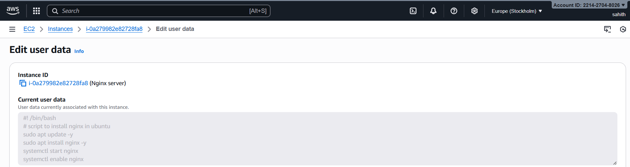
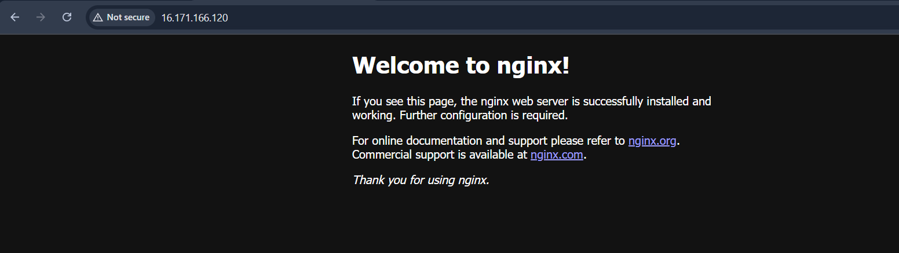
- Launch one Windows server and install Tomcat on Windows.
- Launch instances in aws console in ec2
- Name: windows tomcat > choose AMI: windows server remains everything follow same old steps and launch instances.
- Connect instance > choose RDP client > download the remote desktop file. > click getpassword > browse our .pem file > Decrypt password.
- Use the RDP file + username and password to login.
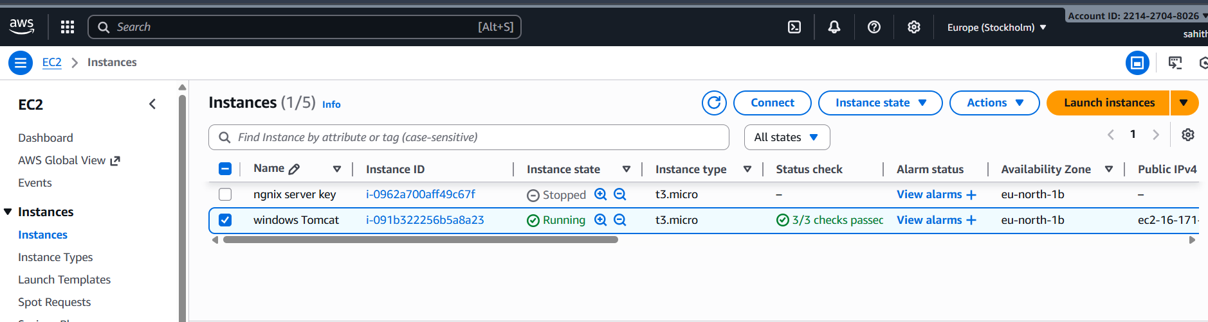
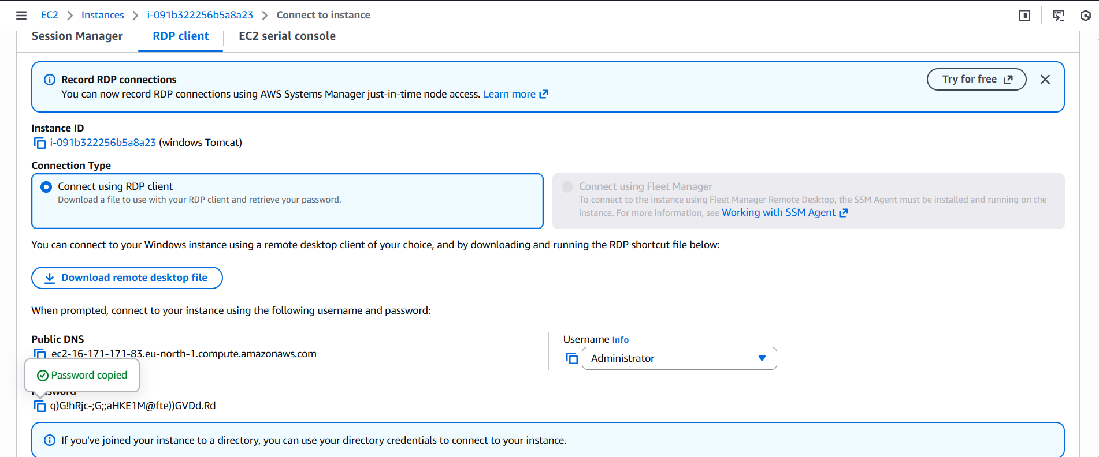
- Install java : open browser in new windows and search for java 17 version
- Install with default settings
- Now download apache tomcat 9 > binary distributions > 64bit windows and download it. Configure
- Using this Http://local host:8080
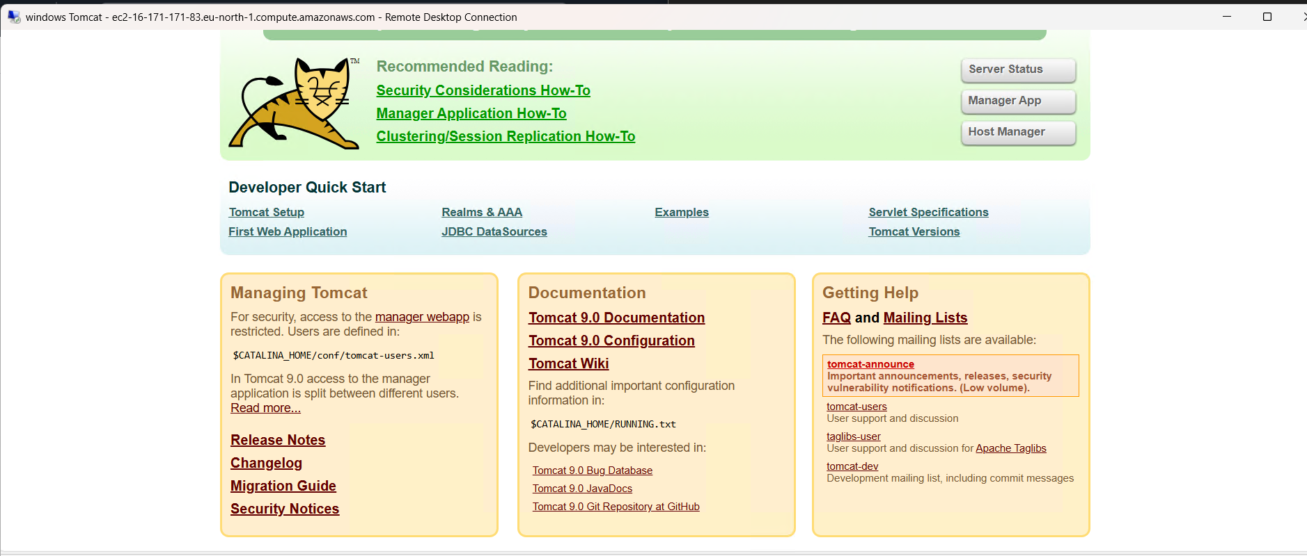
- Take a snapshot of the instance created in Task 1.
- Select the instance > Actions > image and templates > create image.
- Created image and named APACHE Task 1 > create image instances
- Now we created an image created and We get AMI ID. As we can see below.
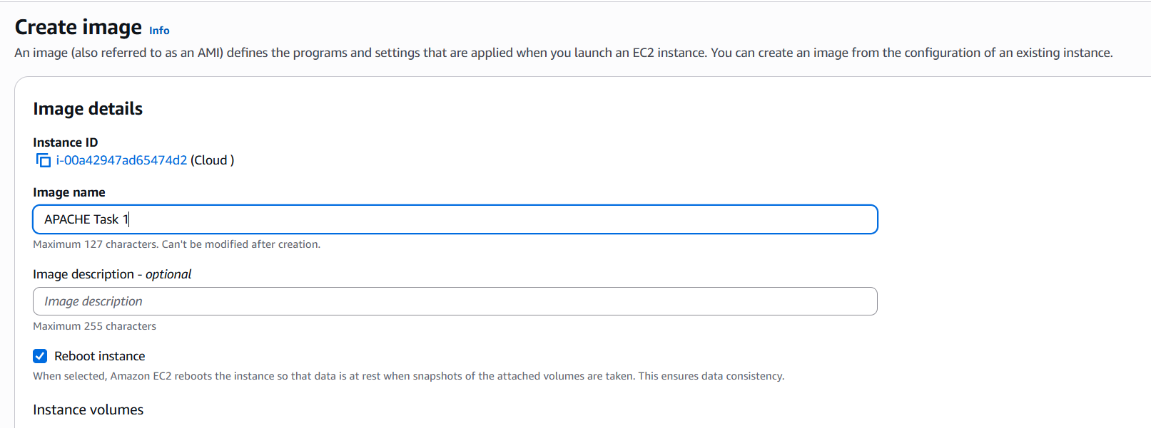
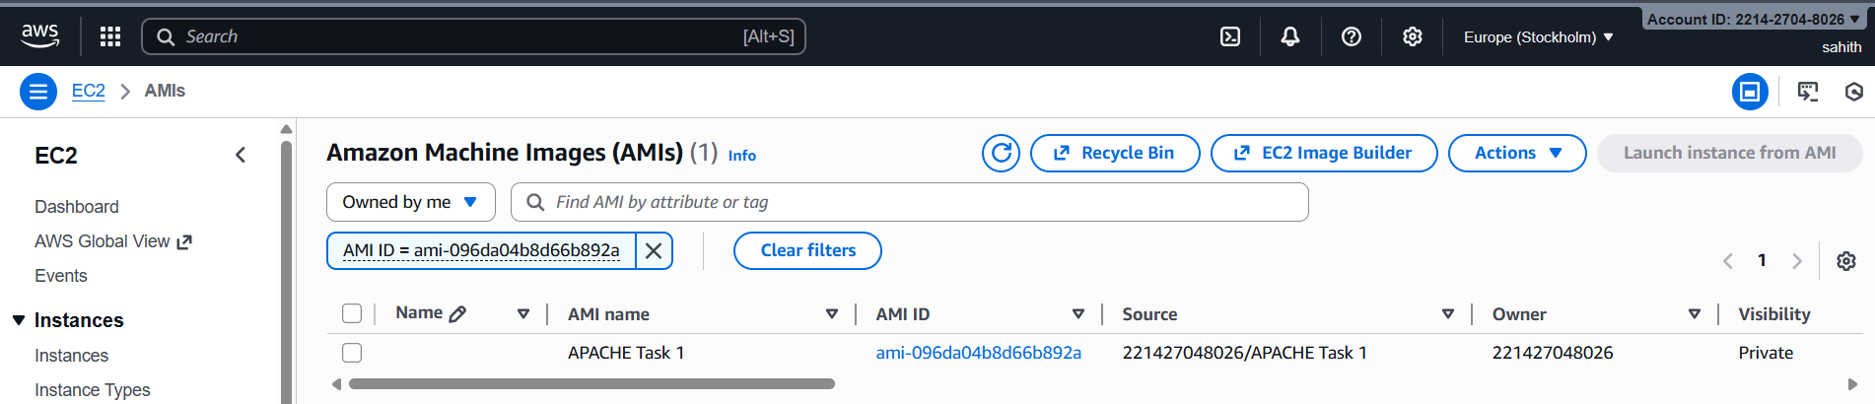
- Assign passwordless authentication for the EC2 created in Task 2.
- First generate ssh-keygen public key
- Aws ec2 nginx server which we created before in task 2. Connect the instances and copy ssh key from their
- Now enter the key in git bash and switch sudo user and ls. Here we can see authorized key
- Now vi .ssh/authorized_key, copy and paste public key here in vi on top.
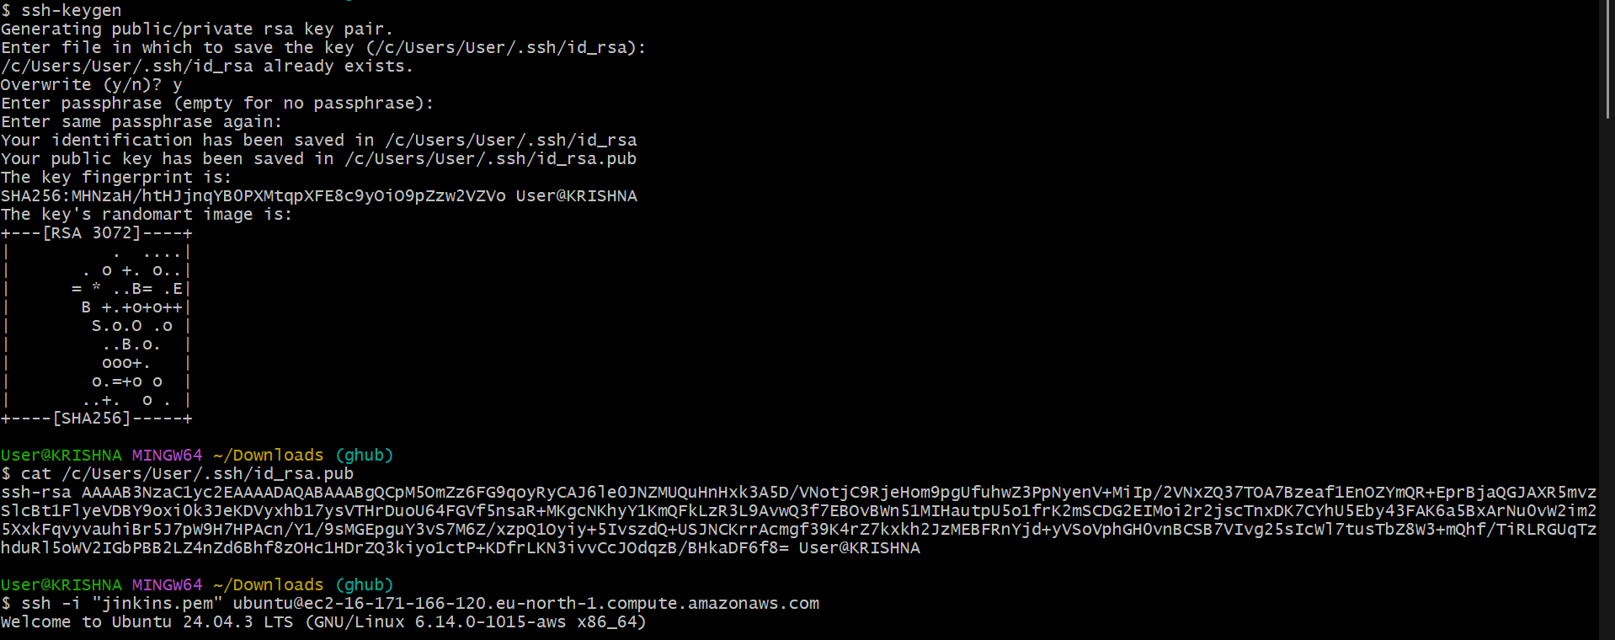
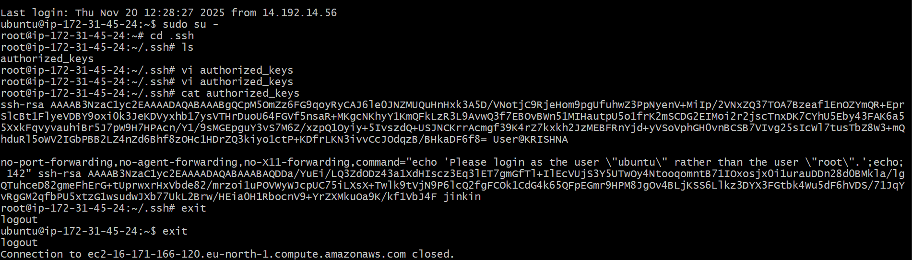
- Now vi .ssh/authorized_key, copy and paste public key here in vi on top.
- Now exit 2 times. Now again paste ssh key which we copyed from ec2 instance. But, remove .pem key from it and enter. We can see status their or we can see permission denied.

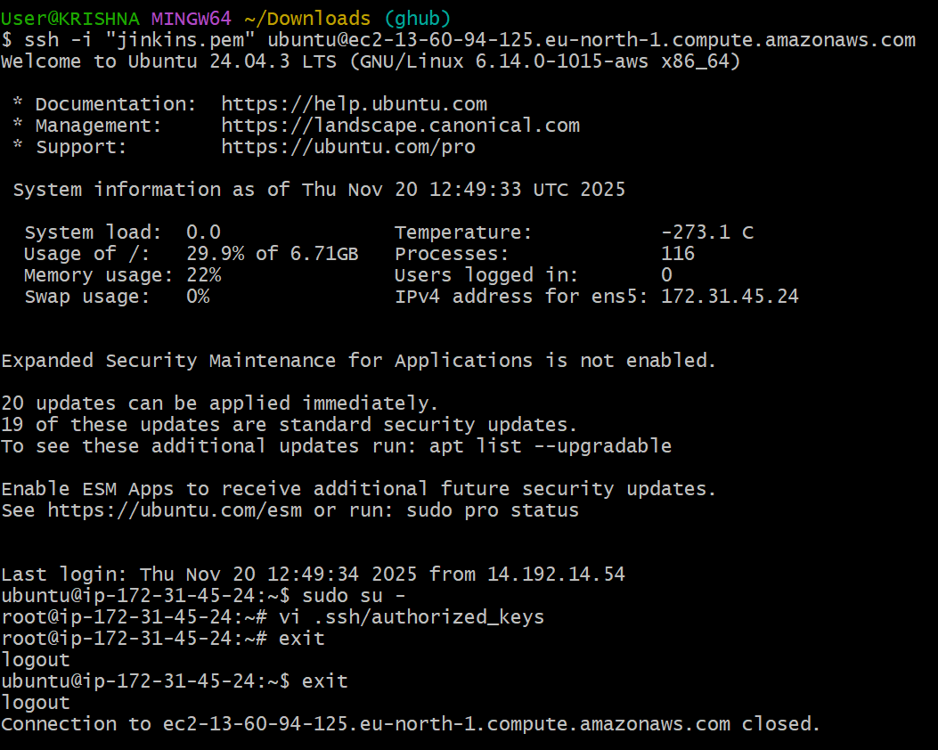
- Launch any EC2 using the spot purchasing option.
- Launch instances enter name > select key pair > Advanced details > purchasing option > select spot instances
- Select customize spot instance options > maximum price select no maximum price, request type select persistent > interruption behavior select stop.
- Do other configurations depends on the requirement and click launch instances.
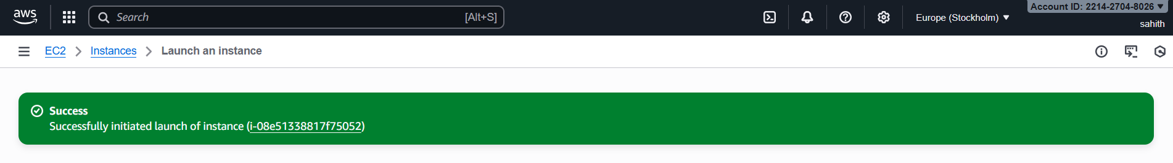
- Enable termination policy on the EC2 created in Task 2.
- Select nginx server > Instance settings > change termination protection > enable termination protection save.
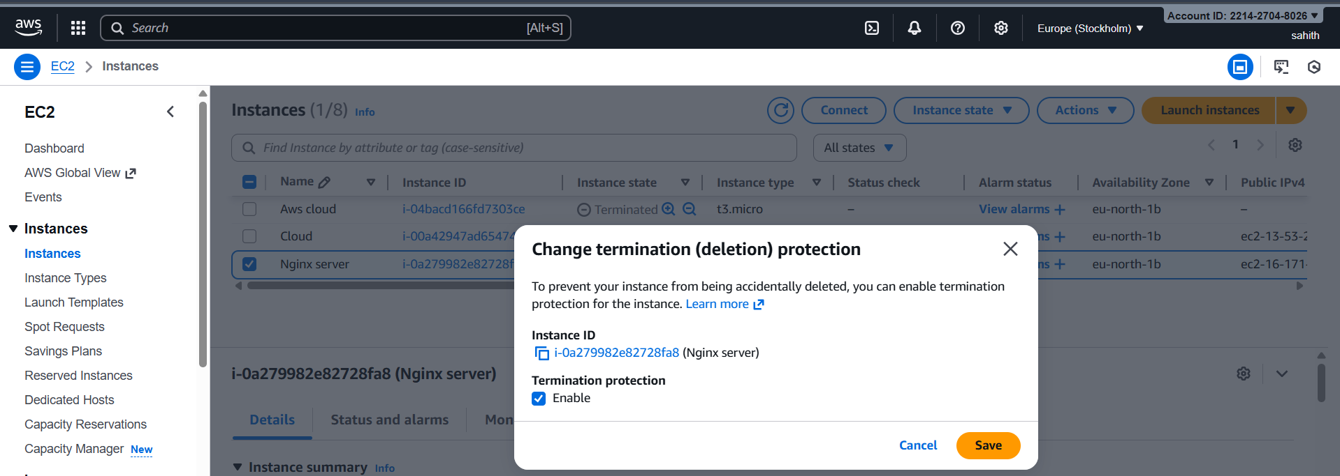

- Launch one EC2 using AWS CLI.

- Key pair created
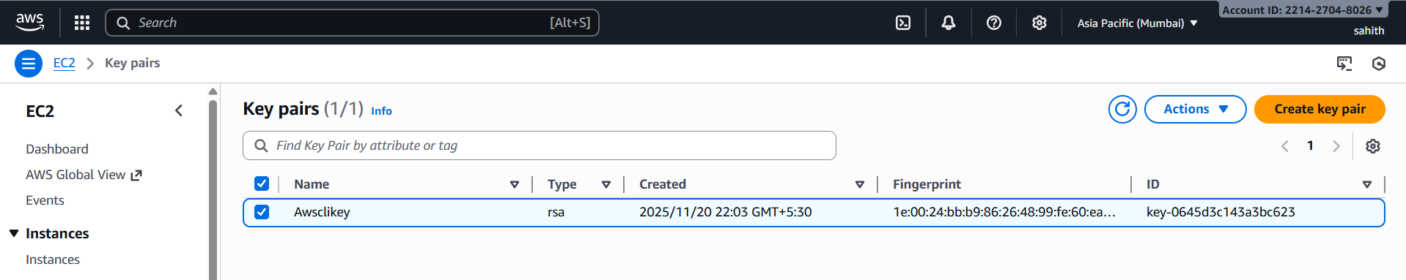
- Aws configures
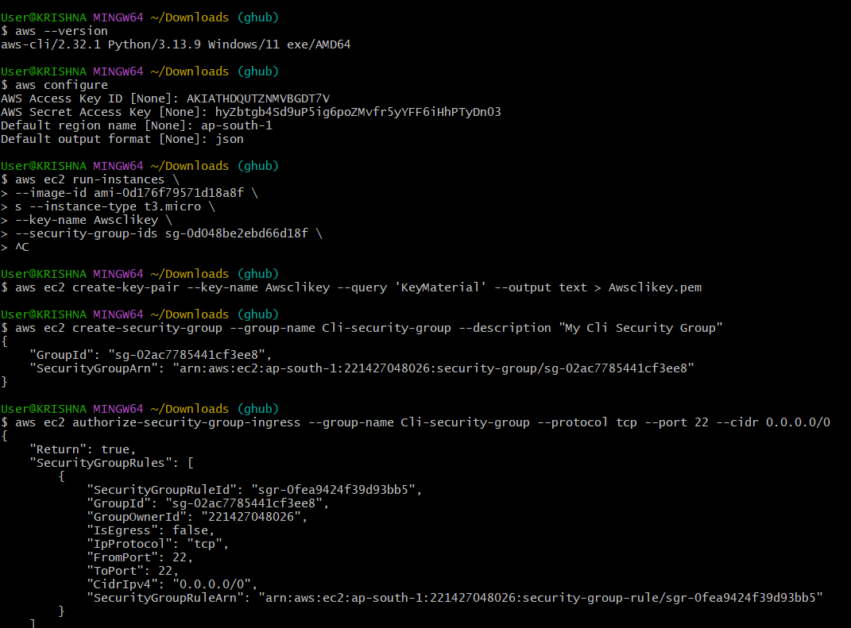

- CLI -security group
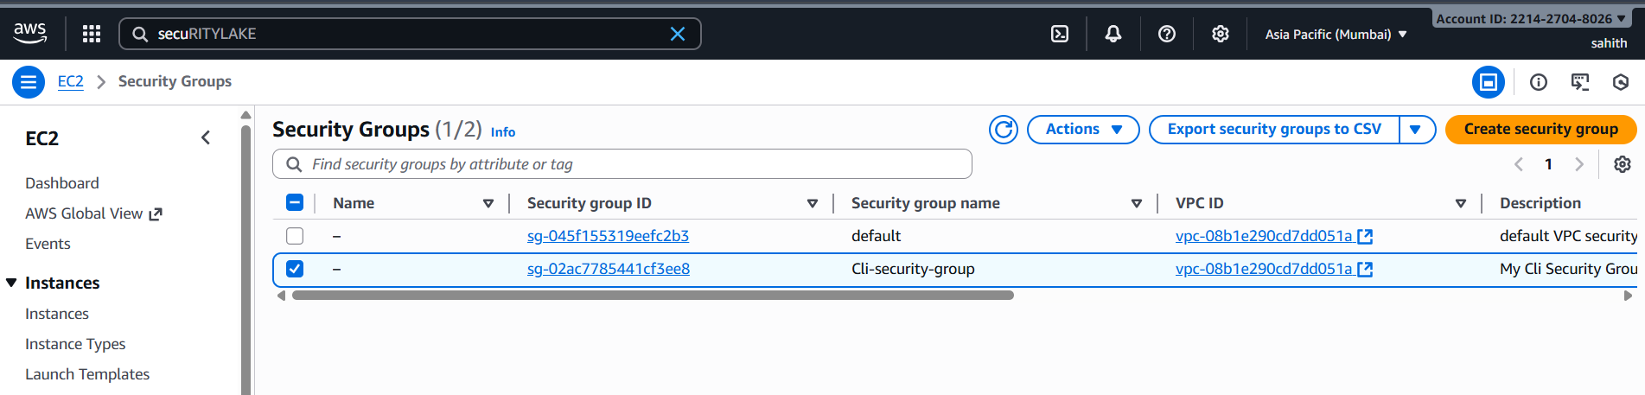
- Launch instance in CLI
